JECRC
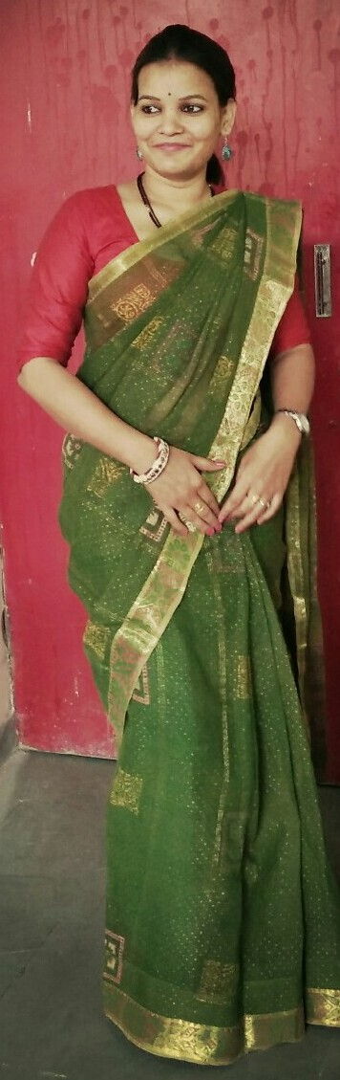
JAIPUR

INDIVIDUAL FACULTY DATA SHEET
Name of the faculty member | : | Brijlata Sharma
Present Designation | : | AP
Email Id: yogesh.ce@jecrc.ac.in
Contact Details: 9261390542

I. Particulars of Educational Qualification: (only completed)

Category | Name of the Degree | Specialization | Year of Passing | Name of the College | Name of the University
UG | B.TECH | CIVIL ENGINEERING | 2014 | RTU, KOTA | RTU,KOTA
PG | M.TECH | WRE | PERSUING | MNIT, JAIPUR | MNIT, JAIPUR
Ph.D.

II. Academic Experience : 3.5 year

III. Industrial Experience :

IV. Title of Ph.D. Thesis :NIL

V. Awards/Achievements : NIL

VI. Research/Specialization :

VII. Course Taught : M.Tech, B.Tech, Diploma

VIII. Refereed International Journal Publication :

IX. National Conference Proceeding :NIL

X. Books Written : NIL

XI. M.Tech Thesis Guide : NIL
XII. PHD Thesis Guide :NIL

XIII. Professional Body Membership :

